Cookie Entrepreneur Pins/Badges
Step 1: Log in to Digital Cookie and Click on the Badges Link
While you are logged in to Digital Cookie, click the link for “Badges” to be taken to the Cookie Entrepreneur Family Pins and Cookie Business badges that your Girl Scout can view and complete.

Step 2: Viewing Badges Page
You’ll be taken to a page that displays the Cookie Entrepreneur Family Pins and the Cookie Business badges appropriate to your Girl Scout’s level.
For the badges, Girl Scouts can read an overview of the steps. For full details, Girl Scouts should check with their troop volunteer or purchase the online requirements using the shop link or from your local council store.
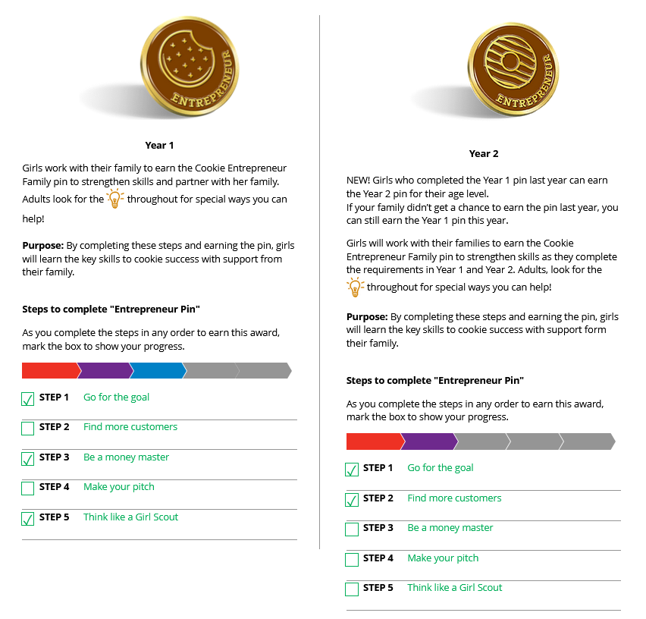
For the Cookie Entrepreneur Family Pins, Girl Scouts can click on the instructions for each step:
Click on a step to view instructions.
Check the box when the activity is finished.
Step 3: View Instructions and Complete the Pin
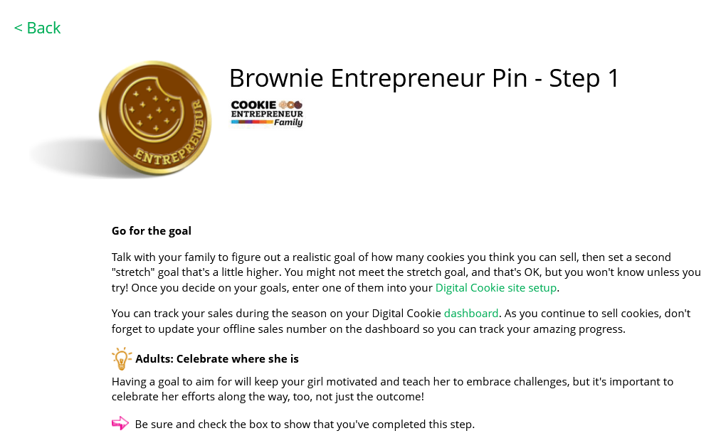
The instructions for each step of the pin will pop up. Click on the link to complete any activities.
Link to activities
Click “Back” to return to badges page and mark step as complete
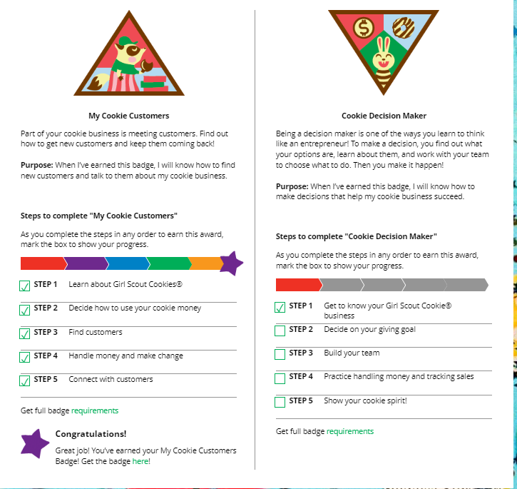
Once completed click the box next to each step; when the box for the last step is checked, a pop-up will appear asking to confirm the last step was completed.
Girl Scouts should let their leaders know when they complete the badge or pin.
Activity Completed-
Girl Scouts can mark the steps as completed even if they finished the badge at another time, like with their troop.
They can also repeat the steps as many times as they like—these are all great tools for entrepreneurs to learn.
Step 4: Congratulations the Badge/Pin is Complete
When all the steps are complete a star will appear at the end of the progress bar and Girl Scouts will get a message of congratulations! Girl Scouts will also see the completed badge or pin in color on their home page.

