**Mobile App for Caregivers and Girl Scouts**

Girl Scouts can use the Digital Cookie Mobile App to process and review orders placed through the Girl Scout’s individual site.

**Step 1: Download the app**

Users will start by downloading the Digital Cookie Mobile App from the iTunes or Google Play store. The app is free and can be found by searching for “Digital Cookie Mobile app.” Users should download a new version or update their app every year.

**Step 2: Logging in to the App**

The email and password used to access Digital Cookie is the same to log in to the mobile app.

The appwill only work if the Girl Scout’s Digital Cookie site is set up and approved, and the council mobile app access date has started.

**Step 3: Selecting the Girl Scout Role**

Once a user is logged into the app they may see different accounts available for theirGirl Scout(s) and troop account(s). This tip sheet will cover the Girl Scout role. To view steps on the Troop role, which will be used at cookie booths, please see the [Mobile App Booths tip sheet](https://www.girlscouts.org/content/dam/girlscouts-gsusa/forms-and-documents/cookie/digitalcookie/Mobile_App_Booth.pdf).

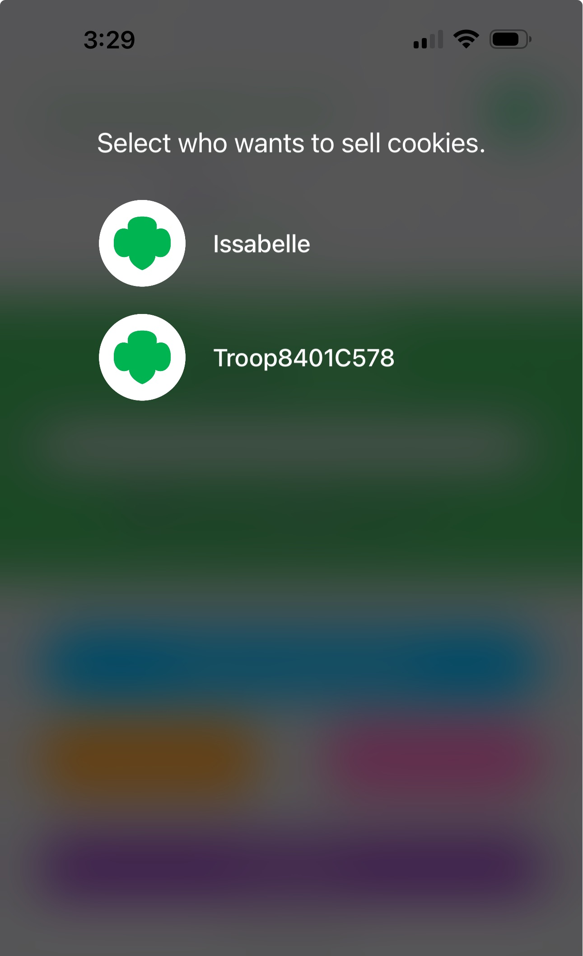Select the Girl Scout name to get started.

**From the home page, the user can select:**

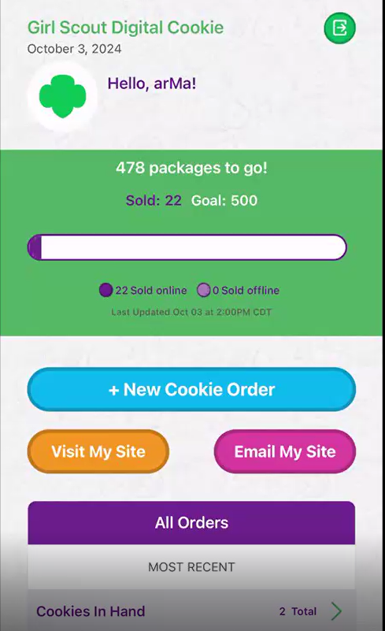

* **New Cookie Order**
* **Visit My Site**
* **Email My Site**
* **All Orders**

**Visit My Site** shows the Girl Scout’s cookie site QR code. The Girl Scout can show a customer the phone to scan which will take them directly to the Girl Scout’s site purchase cookies.

Demo

**Email My Site** is used to send the cookie link to a potential customer who doesn’t want to continue the transaction at the immediate time. The Girl Scout will ask for the customer’s contact information, enter it in the app, and send the email.

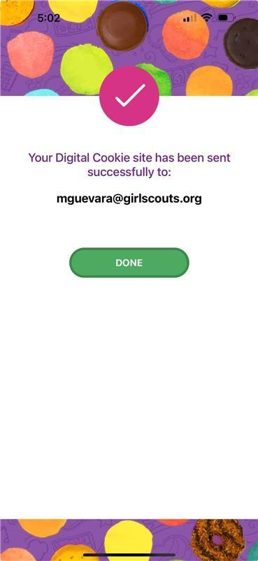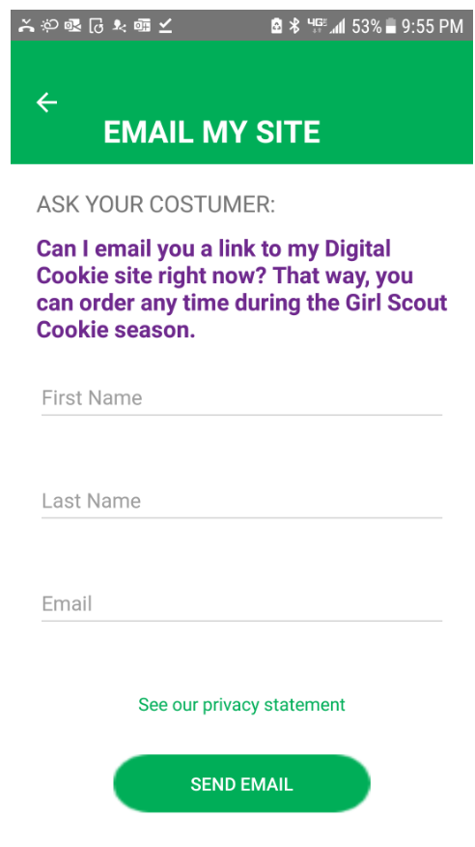The customer will receive an email to purchase cookies.

The customer’s information will populate into the Girl Scout’s Customer tab in Digital Cookie under the Mobile App section. The Girl Scout will need to add the customer to their list prior to sending additional emails or to keep the customer for future seasons.

**New Cookie Order** is used to take cookie orders directly through the app.

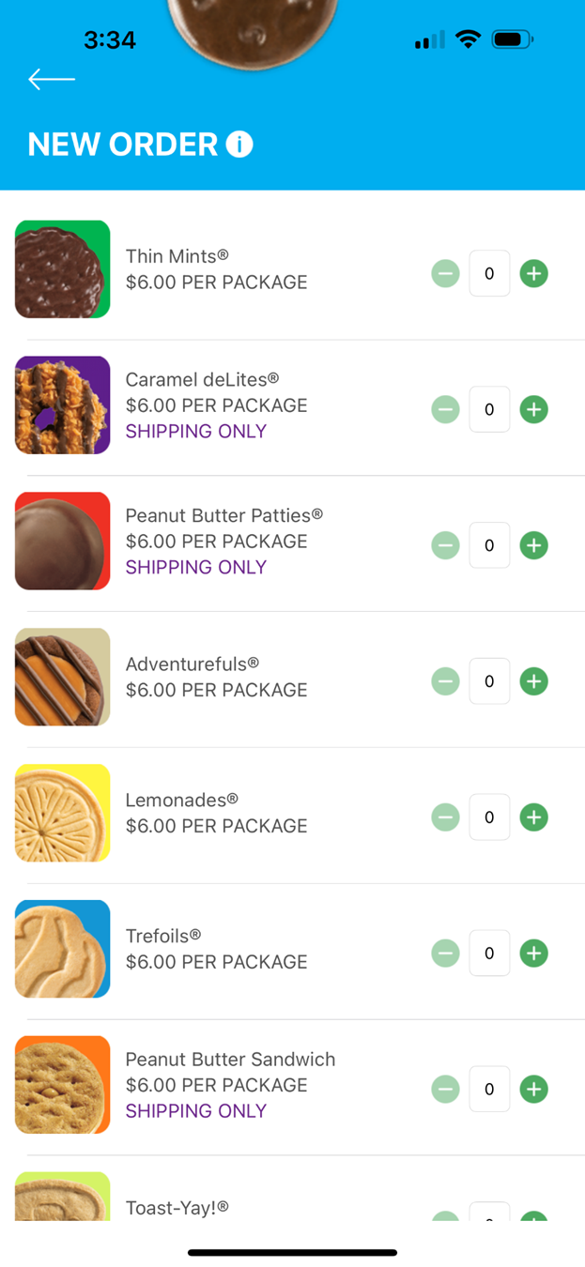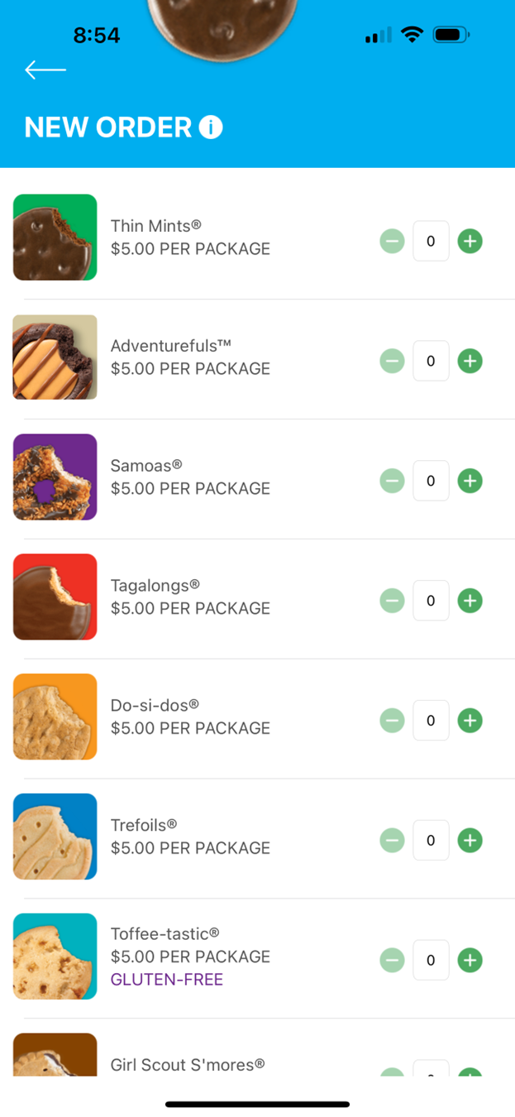**Step 1:** Click the New Cookie Order button to be taken to the order screen to enter which cookies the customer wants to order by using the “+” and “ – “ buttons.

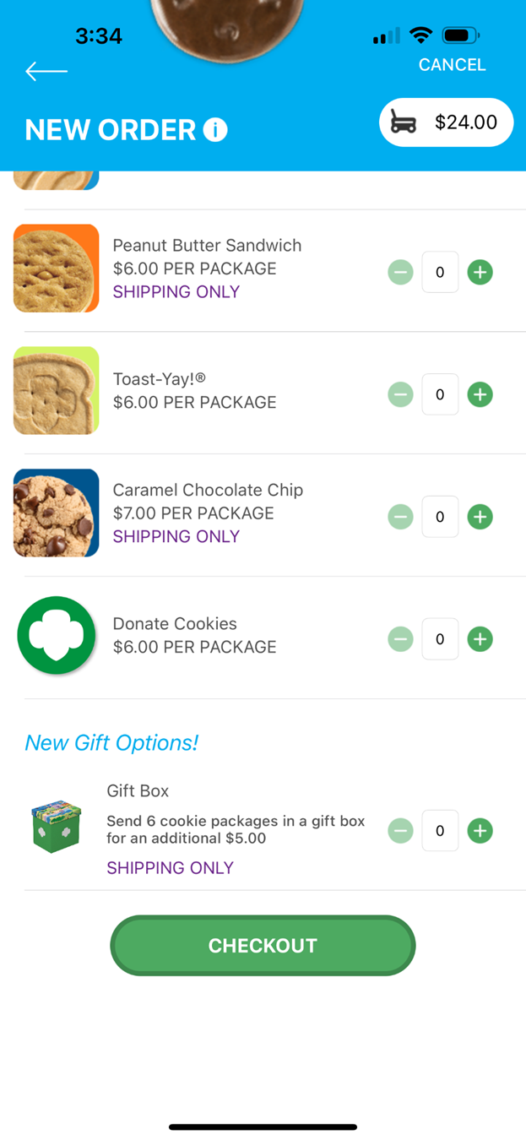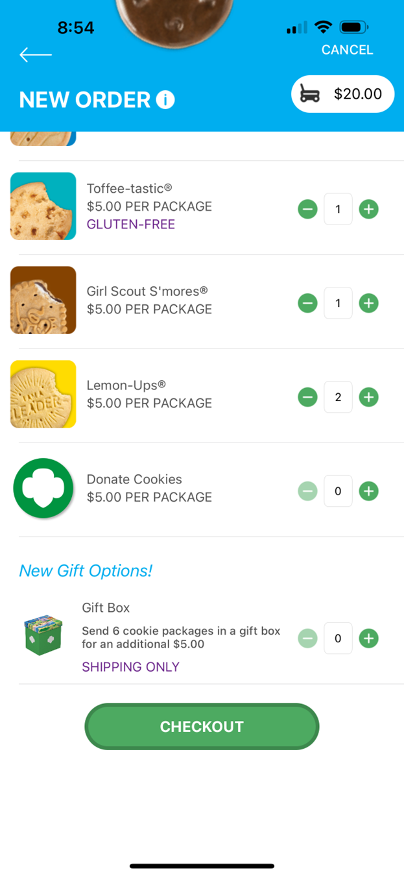Once the correct number of cookies have been selected the Girl Scout will click the “CHECKOUT” button.

**Step 2:** Select how the customer would like to receive their cookies. Options may vary based on what your council has available. After marking the selection, click continue.

If “Deliver in person later” is selected, the Girl Scout will need to ask the customer what they would like to do if their order can’t be approved by the parent within five days. Once the selection is made, continue with the checkout process.

Orders placed for in person delivery through the app still need to be approved by the caregiver.

**Step 3:** Review order and enter customer and payment details. Girl Scout’s can review the order with the customer and gather the customer’s information including payment details.

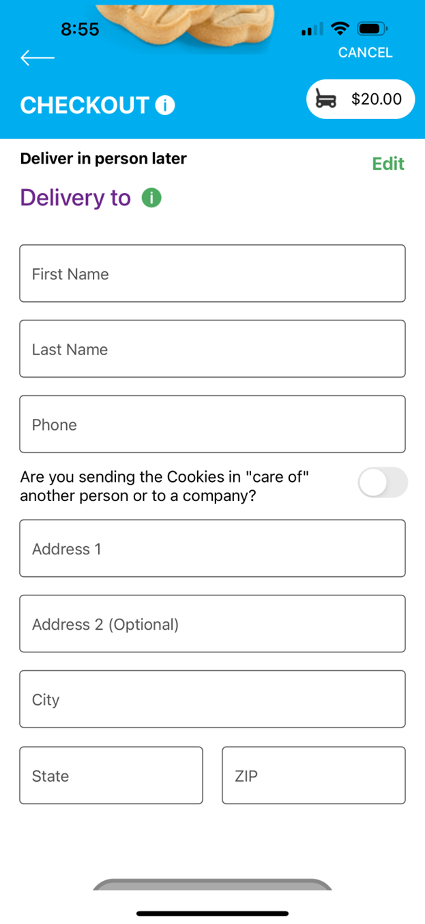If the order is shipped or delivery, the Girl Scout will then complete the customer information for where the cookies will be shipped/delivered to. For in hand orders (give cookies to customer now), customer information is optional.

After completing the required info, click review or place order depending on the order type to select the payment type. The mobile app has three different payment types. **Please Note: PayPal/Venmo is only available when “Give cookies to customer now” has been selected.**

**Use Scan Card feature instead of typing all the details.**

Tip: Have good lighting and double check the numbers before placing the order.

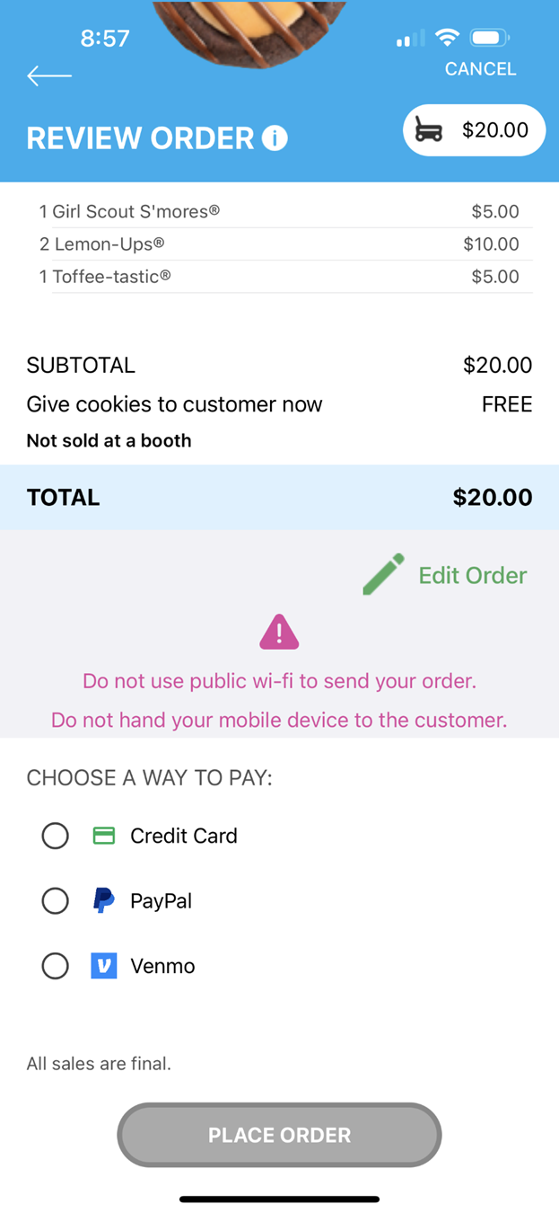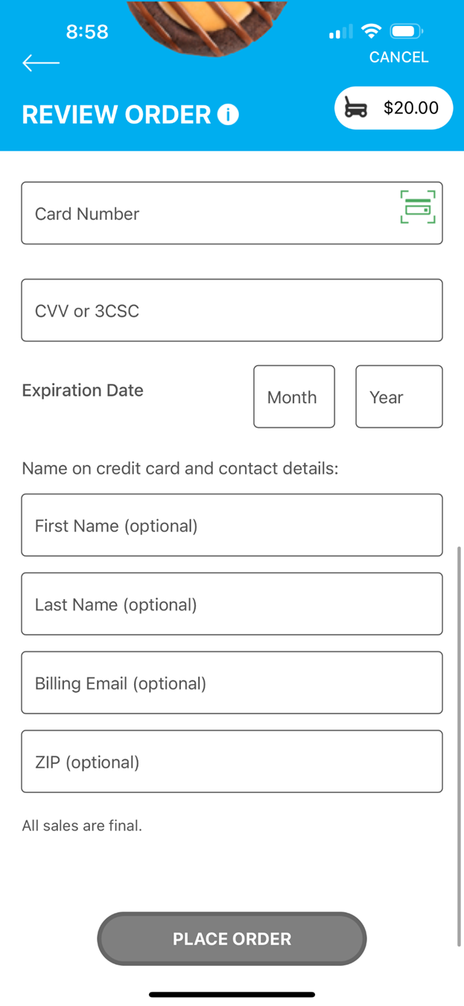

**Credit Card**

When the PayPal or Venmo option is selected and after clicking the Place Order button, a QR code will pop up on the screen. The Girl Scout/Caregiver can turn the phone around for the customer to scan the QR code and continue the payment process on their end.

**PayPal and Venmo**

Demo

Demo

Once the order is placed, the Girl Scout will receive an order confirmation screen and a reminder to thank the customer for the order!

**All Orders** is used to view all of the orders visible by delivery method.

**Step 1:** Click the green arrow to view all orders under that specific delivery method.

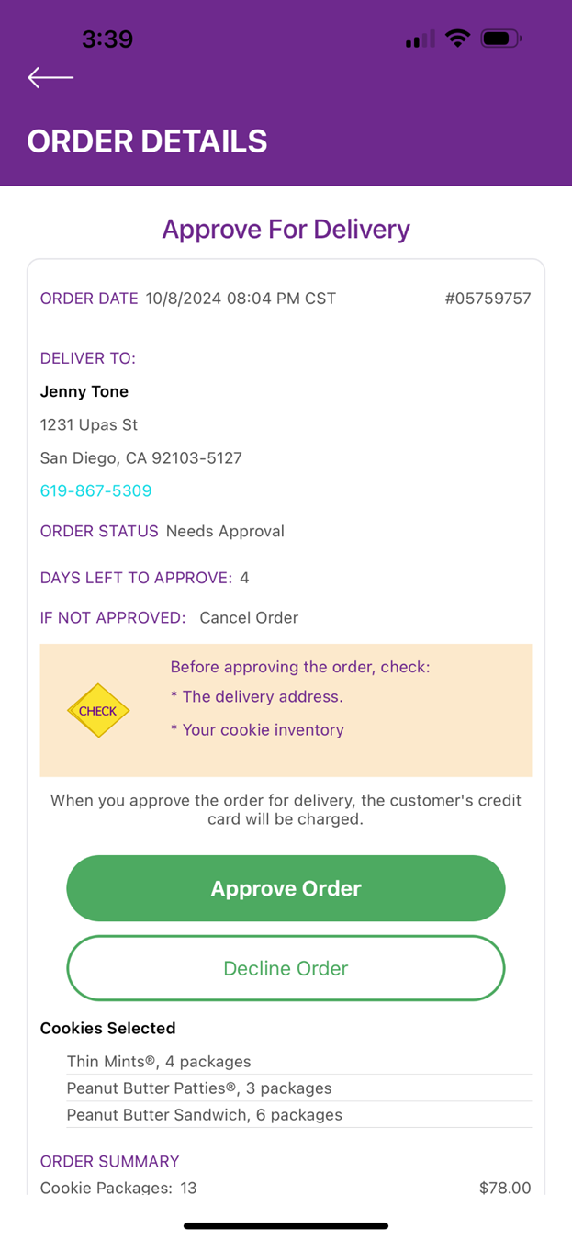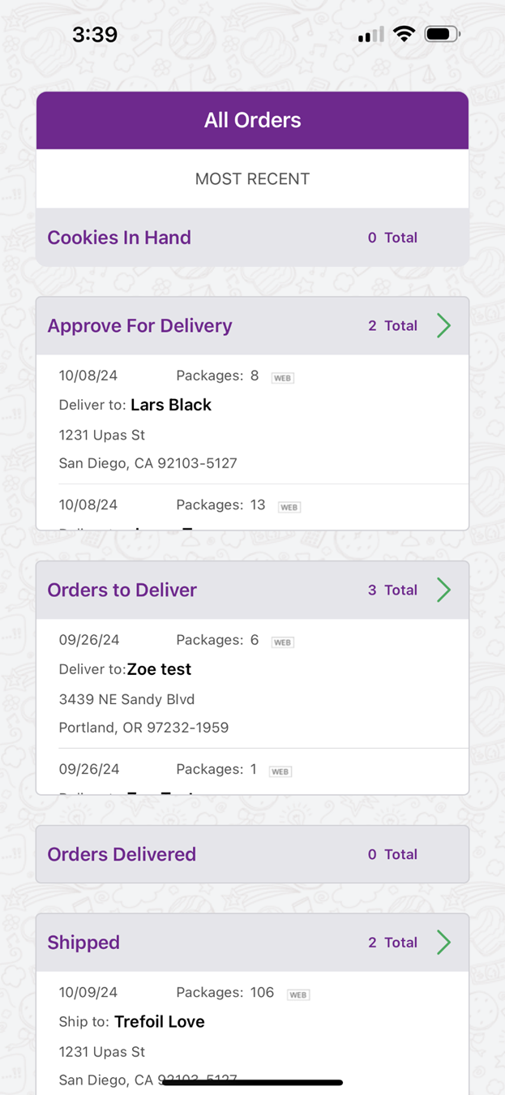**Step 2:** See order details. Click the green arrow next to the order, the details will appear. Users can then review the order, see the status and depending on the type of order and status the user can approve/decline the order or mark it as delivered.

Don’t forget to send those thank you notes!

