**My Account Tab**

Use this tab to update your password or girl information.

**Step 1: Click “My Account”**

While logged into Digital Cookie, click on the “My Account” at the top of the page.

You can either change your password OR click on the “Girl Account(s)” to change the Girl Scout’s preferred name or email address (if 13 or over).

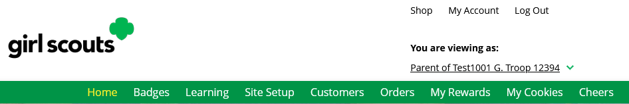

**Step 2:** **Change Password**

Clicking on the “Change Password” will give you the opportunity to update your password

**Step 3: Change Girl Scout Information**

Clicking on the “Girl Account(s)” tab will allow you to update the preferred first name and email address if the Girl Scout is 13 or over.

