**My Cookies: Delivery Settings**

The “My Cookies” tab contains a number of different functions for parents. This tip sheet explains the “Delivery Settings” portion.

If enabled by your council, the Delivery Settings function lets yourn off the In-Person delivery option for customers or turn off varieties of cookies for in person delivery. You might want to use this if you are out of a cookie variety and can’t get more, if you are entirely out of cookies for delivering to customers, or if your family is unable to deliver cookies to customers. Turning it off means a customer won’t purchase something your Girl Scout can’t fulfill, requiring you to decline their order and disappoint them.

If you are worried about your inventory, always check with your troop cookie volunteer first to see if you can get more cookies before turning off a variety.

**Step 1:** **Turn off In-person Delivery**

When you select “inactive” to turn off the Girl Scout delivery option for your customer, you will get a warning message. If you want to turn delivery off, click “Update delivery settings”.

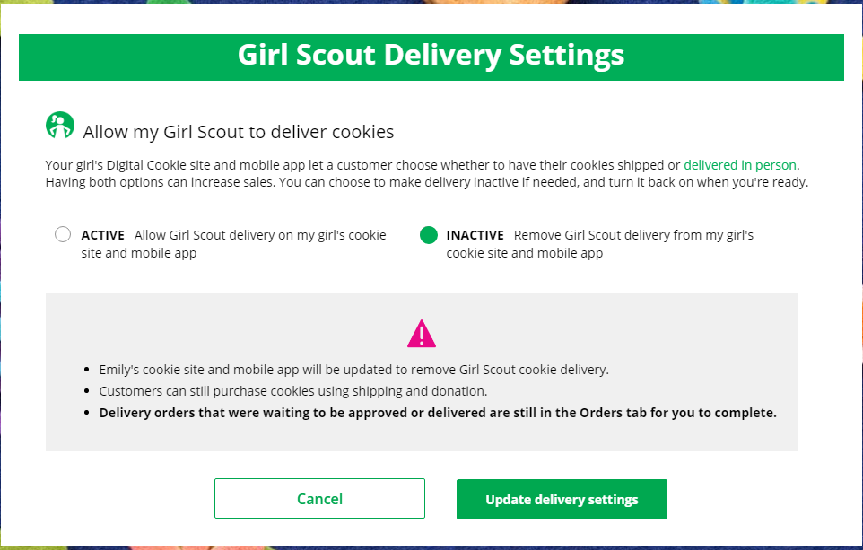

Once you have turned it to inactive, the varieties section will be removed and is supereded by the active/inactive setting. You do not need to turn off each of the varieties individually if you set it to inactive.

Should you wish to turn delivery back on, simply click “active” and your customers will see delivery as an option again. Make sure you click “Update delivery settings”.

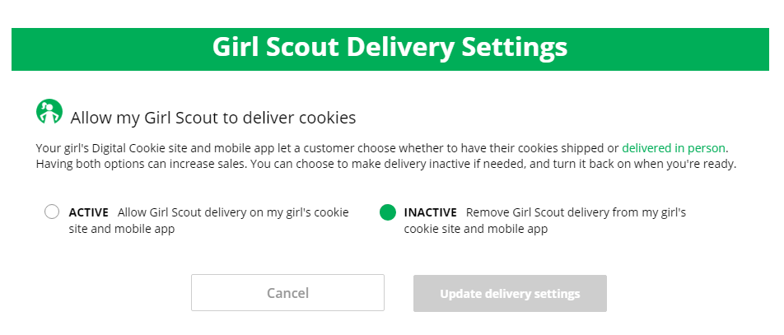

**Step 2:** **Turn Off Cookie Variety for In-person Delivery**

If you wish to offer delivery but are out of a cookie variety and can’t get more inventory, you can turn off just the out of stock variety of cookie for delivery and customers won’t see them as an option for their delivered order.

To do that, simply click the “off” slides next to the cookie variety, then click the Update delivery settings button and it will remove that variety from the Girl Scout delivery option. If you are able to offer that cookie to customers again, return to this section and click the “on” slider to turn that variety back on.

