**My Cookies: Financials**

The Financials section is a valuable tool to help you understand the amount due for the cookie sale and how the troop is calculating the amount.

To access the financials section, you will click on the tab labeled “My Cookies” on your Digital Cookie Dashboard.

In that tab, there is a section for “Financials”. Note, this section will only appear after the Initial Order (if applicable)

Using the “at a glance” view is a great way to see the overall amounts paid and due. If you need more detail, you can expand any of the sections to find out more.

There are four sections to your financials that you can expand to get details.

* [Initial Cookies (Order Card)](#_Initial_Cookies_(Order)
* Additional Cookies Received
* Payments
* Total Balance Due

# **Initial Cookies (Order Card)**

*This section may not apply to you based on your council’s sale type.*

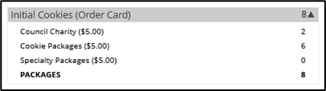If you expand this section with the arrow, you will find information on the initial packages you received at pickup, minus any packages you received for in-person delivery orders because those were pre-paid and you do not owe for those.

You will also see any Gift of Caring (Donated) packages that you had orders for.

NOTE: Cookie and Specialty packages may apply if your council sells cookies at two different pricing tiers. Contact your troop cookie volunteer for additional information.

## **Additional Cookies Received**

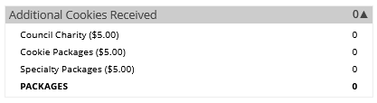The categories are the same as the Initial Cookies but reflect packages transferred to you from the troop. For any questions about this or if this figure does not reflect the packages you picked up, please contact your troop volunteer.

**Payments**

Online Paid: This reflects any online payments you received for In-Person Delivery, Donation or Cookies in Hand orders.

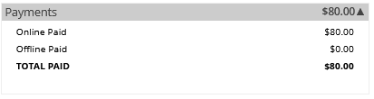Offline Paid: This amount is any payments for cookies received offline, generally cash or check, that you have given to your troop volunteer that they have entered.

If this does not match your records, contact the troop cookie volunteer to help understand the differences.

## **Total Balance Due**

Total Money Owed: The amount you owed for the cookies received at initial pickup and additional cookies received. Note, if your council sells cookies at two different prices, that has been accounted for in your money owed.

Total Money Paid: The total from the “Payments” section.

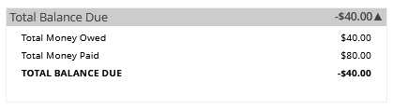Total Balance Due: The difference between the amount owed and the amount paid.

If you think any of the figures in this section are incorrect, contact your troop cookie volunteer to compare the information on file for you from what you think this should be.